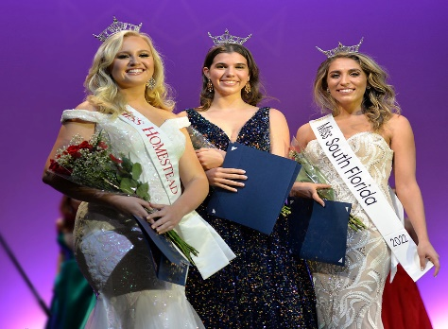
Thank you for your support in 2022. We are hoping to hear from you this year. It is my pleasure to offer you again, your company the opportunity to become a Sponsor of the Miss South Florida Scholarship Program, Inc. The Miss South Florida Scholarship Program is a voluntary organization dedicated to offering scholarship opportunities to young ladies between the ages of 13- 28 years in the South Florida Community. The main reason of our success has always been the incredible support we have received from sponsors who have been behind us every step of the way. The money obtained by this Program through donations and fundraisers goes towards Scholarships and expenses for competition at the State level. In addition, we are extremely proud to be part of the Miss America Organization, which contributes to many leading achievement programs and is one the world's largest provider of scholarship assistance for women. The Miss America Organization and its state and local organizations have made available more than 45 million in scholarships for women.
We rely on the support of individuals and local businesses to help provide these scholarship services to young ladies in the south Florida area. We hope you will join us in supporting these outstanding women by contributing in one of the following ways.
DEADLINE: March 1, 2023
Make checks payable to “The Miss South Florida.”
Mail checks to: Myrna Cotto 4112 NE 24 St., Homestead FL 33033; email ads to mcotto@avionica.com
Patron Sponsorship (please check one or more):
□ Scholarship Patron ………. $500 (includes 4 reserved seats and name or full page Ad in program book)
□ Crown Patron ……………..… $250 (includes 2 reserved seats and name or ½ page Ad in program book)
□ Sash Patron ………………….. $160 (includes 2 general admission. Tickets and name or ¼ page Ad in program book)
□ Silver Patron ……….………… $ 50 (includes 1 general admission. ticket and name or business card in program book)
□ Friend Patron ………………… $ 10 (includes name in program book)

Scholarship and Miscellaneous Contributor (please check one or more and provide details):
Donations of any dollar amount, product, or service such as: Scholarship Contribution, Flowers, Meals, D.J., Judge’s Hotel Stays, Winner’s Prizes, etc., will receive special recognition in Program Book and by Emcee.

□ $______________, for (preferred type of contribution) __________________________________
□ Product or Service _________________________________________________________________
□ $ __________, Community Service Scholarship in Honor of Beatrice Meza-Andrews, MSFSP founder and retired E.D. - includes 2 reserved seats and name or ½ page Ad in program book. Maximum Scholarship is $250, excess monies will go towards misc.

Sponsor Name: _________________________________________________________________
Sponsor Address: ________________________________________________________________
Sponsor Telephone: _____________________ Sponsor Email: ___________________________

The undersigned hereby subscribes for the above referenced advertising/sponsorship for the Miss South Florida Scholarship Competition Inc., program book. Ads submitted should be camera ready or there will be a $25.00 set up charge.

Signature: __________________________________________________________________

